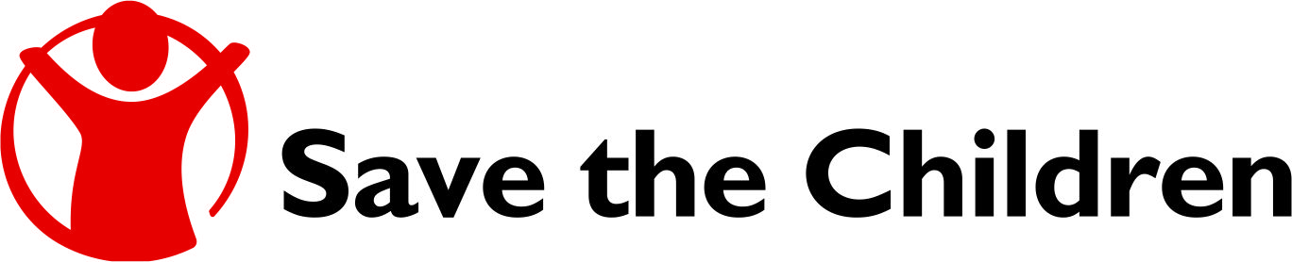

**Small Grants Help Refugee Families to Get Back on Their Feet**

Marat, 26, is a young entrepreneur in Yerevan, Armenia.

His family moved to Armenia from Baku, Azerbaijan 25 years ago when Marat was a one year old child. Their family of four – Marat, his sister, mother and father - settled in a small village. They had to overcome numerous hardships as they built their life without job and family income opportunities.

Later on the family moved to Yerevan, Marat’s parents found jobs, and the family livelihood gradually improved.

Yet another sorrow happened to Marat’s family when he was 17. His father died, and Marat had to begin working so to ease the burden of feeding the family.

After several years of doing various jobs, he finally founded his private entrepreneurship and became self-employed, repairing and servicing printers. However, he had almost no money to invest in his company.

“I had only a couple of working tools, a bag, and a very limited amount of spare materials. The amount of money I earned was too modest to invest in my business,” Marat said. “When I got calls from the clients, I first tried to understand what’s wrong with the printers, bought the necessary material and took it to the client. Sometimes I had to borrow money from my friends and returned my debt only after I was paid by the client.”

The grant received from the Assistance to Refugee Families in Armenia (ARFA) project allowed Marat to buy two printers as well as a lot of supplies such as printer cartridges, accessories and parts. These things significantly promoted his business and, consequently, livelihoods.

“The grant was very helpful especially because I received it in summer which is an off season for computer business. If not the grant, I would borrow a lot of money from my friends to survive. Thanks to the grant, I did not have to purchase printer accessories, and received almost 100 percent profit from my work,” the young entrepreneur continues. Having the spare parts at his disposal, he was able to take more orders than usually and provide better quality services.

Moreover, Marat could save some money for other family needs. For example, when the sanitary appliances of their bathroom were changed through another component of ARFA project, he renovated the entire bathroom with the money collected.

“We have been here for 25 years and we never relied on the support of the state or organizations. We did not believe that someone would be willing and able to help us, but later I understood that Save the Children is the organization I can trust.”

Just like Marat, 16 more refugees and their families benefitted from the small grants component of ARFA project. The latter aims to promote the wellbeing of the most vulnerable refugees in Armenia. With funding from the US State Department’s Bureau of Population, Refugees and Migration, ARFA was implemented in five communities (Nizami, Khachpar, Hayanist, Darbnik and Masis) in Ararat marz, four communities (Abovyan, Hrazdan, Kasakh, Yeghvard) in Kotayk marz, and seven administrative regions (Shengavit, Nor Nork, Erebuni, Malatia-Sebastia, Arabkir, Kentron, Ajapnyak/Davtashen) of Yerevan that are most densely populated by refugees from Azerbaijan, Iraq and other countries.