**Empowered children**

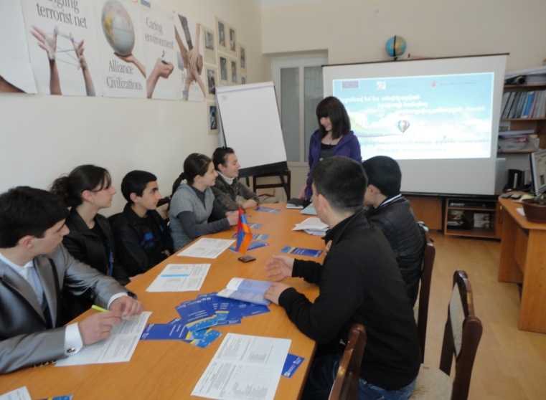

***Empowered children empowering others***

Since November 2011, 16-year old Marlena Manukyan, who lives in Gavar Orphanage, has initiated public awareness events in Gavar, after being actively involved in the Child Protection Team of the community. During 6 months, she had organized four events on child protection topics with the purpose of sensitizing and engaging the active members of the community. Around 100 university and school students, teachers, regional administrators and NGO members had participated in her seminars. In her initiatives Marlena paid special attention to the children with special needs, by involving children and teachers from local special school.

As a result, the number of young enthusiasts in child protection has grown in the town, so as now she has a whole team to run her campaigns. Accordingly, with a group of active high school students Marlena plans to commence a pan-regional campaign in September, 2012, with a purpose of raising awareness among larger public.

***Empowered children protecting themselves***

15 year-old Anahit Maghakyan, who is an active member of UCSF Child Protection Team in the town of Abovyan, proved to be enough empowered to raise her voice against a child violence case at her school.

In May, 2012 when her classmates had skipped a class, the teacher decided to punish the whole class. It was only Anahit who did not allow the teacher to raise a hand on her, and reported about the case of physical violence to all relevant bodies – school administration and the regional Child Protection Unit. Now children feel more protected at school, knowing that there are bodies, who will deal with their cases and will help them.

**Positive parenting**

***«Safe me, Safe you» books helping not only children, but also parents***

On March 5, after an open lesson at the #164 secondary school in Yerevan, 74 participants felt extremely inspired and happy. Through an interactive and student-centered lesson children learned about their rights and their execution in their daily lives. The teacher used «Safe me, Safe you» handbook specifically created by Save the Children, to educate children on child protection issues.

By participating in the lesson, children now can identify what is violence, how they can be protected against it, or where they can seek a help in the case of a violence risk.

Besides the children, the lesson was highly education for parents as well. Many of them mentioned the invaluable assistance that the seminar gave in terms of talking about sexual violence to children. In fact, many parents find difficult to talk to their children about it. «This was an ideal way of informing our children about sexual violence. I always knew that I must talk to my children about sexual abuse, but I never dared to do that. I didn't know how to explain all that to them. Now I am happy that you have opened up the conversation, and I know how it needs to be continued» - said one the participating parents in the seminar.

***Rethinking parenthood***

Gayane Davtyan, a history teacher at Sisan secondary school is having tearful eyes when talking about child violence. «I thought I was disciplining my son, but it turns out that I caused immense pain to him» - she says. After being involved in Sisian Child Protection Team and being trained on Child Protection and Positive Parenting topics, Gayane had reflected on her parenting experience. She regretted all her slapping and offenses to her eldest son, who is in the army now. She firmly states of having changed all her disciplining practice thanks to the child protection and parenting seminars of UCSF program.

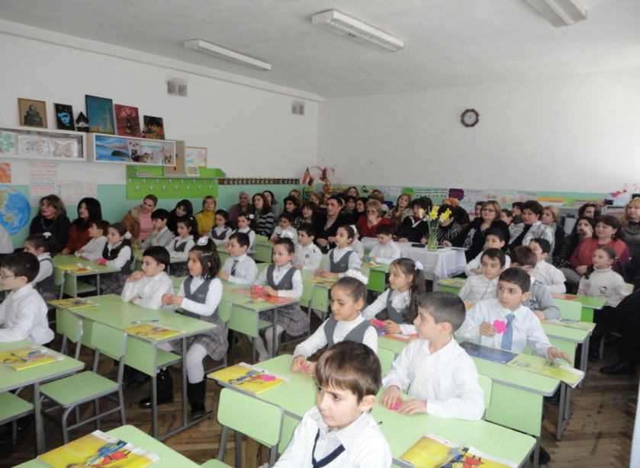

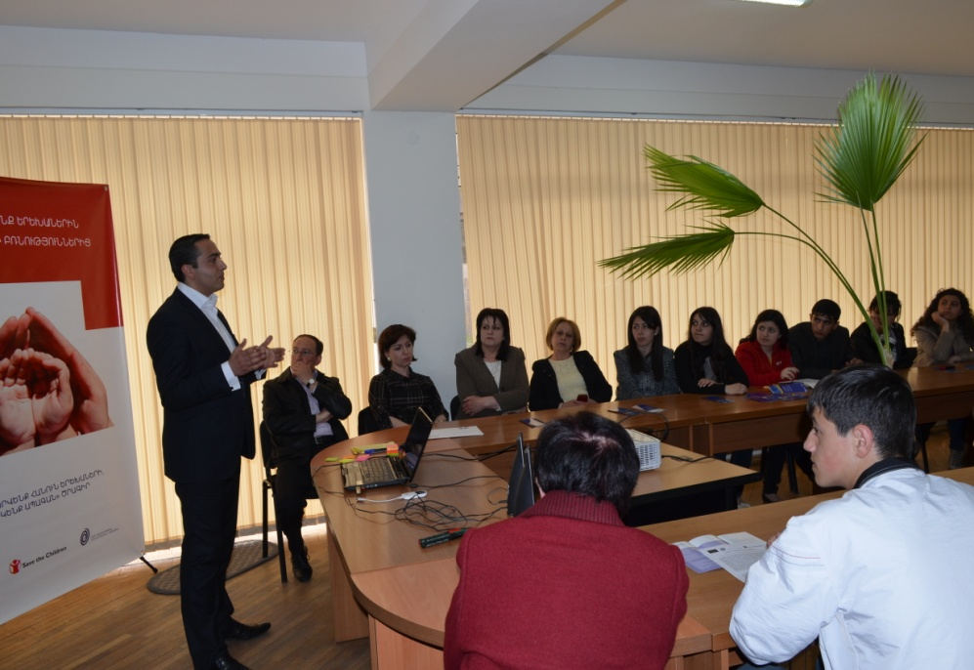**Open-minded administrators**

***Community administrator living a change***

Before participating in Child Protection seminar, a 24 year-old Ara Mirzoyan, the assistant to the head of the region, was highly skeptical about the issue. He was fiercely opposing against the term of violence and rejecting its practice in the community. Moreover, he considered parental slapping and insults as a way of disciplining children for their own benefit.

However, after participating in a Child Protection information session at «Goris youth union» NGO in January 2012, Ara suddenly changed his standpoint. “Now I understand how relevant and urgent the issue is» - as he mentioned to the trainer.

Right afterwards, he has initiated advocacy events on child protection issues. Voluntarily, he has organized two events with participation of 60 persons targeting university students, journalists, school councils and NGOs in the town. Moreover, he initiated to tackle a case of sexual violence in town trying to help the integration process of the victim and the community.

At present, in the person of Ara Mirzoyan there is an enthusiastic «child protection officer» in town, who is eager educate community members and prevent any violence against children.