Cross Project Collaboration

Education Quality and Building Conditions Improved at Goris Kindergarten #2

Kindergarten #2 in Goris town of Syunik province in the South of Armenia is included in two projects of Save the Children: “From Childhood to School” and “Early Childhood Development” funded respectively by the UNICEF and The Lincy Foundation.
“From Childhood to School” project improves accessability of early childhood development (ECD) services for underserved children through preschool classes. The project works hand in hand with parents, teachers and local authorities of eight kindergartens in Syunik province in order to ensure their active involvement in early childhood development activities. Around 200 vulnerable kids, most of which had not attended kindergartens, have been included in the project. 27 teachers have been trained to ensure the children’s smooth transition from kindergarten to school. Project Support Teams have been formed from the stakeholders to assist the project implementation. The preschool classes were set up with furniture, literature, stationary and toys.
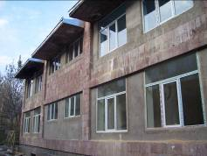
Goris kindergarten #2 under renovation
“Early Childhood Development” project improves physical conditions of four kindergartens in Armenia, including full renovation, provision of running water and heating systems. The project also promotes interactive teaching methodologies in pre-schools through trainings for teachers and nurses. Goris kindergarten #2 benefits from this program as well.
The collaboration between these projects helps children of Goris kindergarten get quality ECD services and have easy transition from childhood to school.

A Boy’s Story: From Childhood to School

Eric, 6, had never attended a pre-school. He lives in town Goris in the farthest from Yerevan Province of Syunik. “The kindergartens in our area are in dire conditions,” says his mother, Hasmik. “I feared for my son’s health and security, since it was cold in winter in the kindergarten, there was no running water there and I didn’t trust in the teacher’s attitude towards children either. Besides, my family couldn’t afford to pay kindergarten fees. In short, I preferred to keep my child at home and thought it was the best choice for him.”
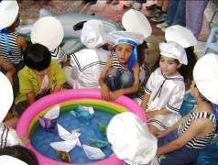
At the kindergarten performance
In the middle:
Eric has just launched his paper boat
But as the time passed Hasmik realized that Eric gradually became unsociable and aggressive. He refused to go anywhere without his mother and was very unfriendly to other kids. Meanwhile, due to education reforms in Armenia, school age got down to six instead of former seven. “As his school age approached, I panicked: How would my child get used to school?”
One day Eric had a visitor. It was a representative from Save the Children’s “From Childhood to School” initiative. She said that the project created opportunities for children like Eric - outside the kindergarten and close to school age - attend pre-school classes for two months. Hasmik was delighted to learn that Eric could attend the classes at the kindergarten. Yet things were different with Eric...
“His first days at the kindergarten were very difficult. He didn’t want to play with other kids, cried and kicked everyone who came close to him,” remembers Zhasmen Khachatryan, Kindergarten Director.
“Eric’s behavior was peculiar to the other kids who didn’t have access to kindergartens and first attended it during the project. These kids were either aggressive or too self-contained. Our teachers worked hard to help them get integrated into the new environment,” says the Director.
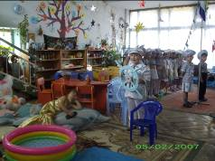
Children staging a final performance
at the kindergarten
Their efforts proved very effective. Just in several days Eric began playing, singing, dancing and reciting with children. “I like it here, Mom,” once he said. “I don’t want to stay at home. Take me to the kindergarten, please.”
“I’m so sorry that I didn’t take my child to the pre-school before,” says Hasmik. “Those two months meant so much for him! He learned to associate with others, and also got ready to school.”
Children marked the finishing of pre-school classes with staging a wonderful performance which clearly demonstrated their new skills and behaviors. “Now Eric is a pretty successful first-grader,” says Hasmik with satisfaction. “I thank the teachers, Save the Children and the donors for it. Without them, it would be very difficult for my child to get used to school.”

