An Iraqi Armenian Refugee Finds a New Life in a New Country

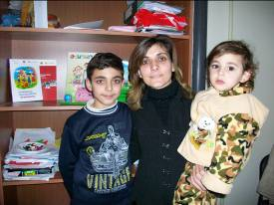
Anahit with her two children, Arman, 12 and Pargev, 2

Anahit, 33 is one of thousands of Iraqi-Armenian women who fled from Iraq to escape the war. "When the war began, we fell into hell," she said. "Not a single moment could I feel secure for me and my family. Not being able to bear that any more, we finally fled across the border in search of peace and a better life."

But new hardships were waiting for them in the Armenian village where they settled. With little income, the family had to spend the last of their savings. They moved to Yerevan, where Anahit's husband found work, but Anahit remained jobless. She said, "I was dreaming of a job, but definitely lacked language and other skills."

Then Anahit joined Save the Children's Acculturation through Learning program for Iraqi-Armenians. With her newly acquired fluency in Armenian and Russian and improved computer skills, she took an intensive training course in child care and began working for Save the Children's child daycare center. The job has helped her acquire professional credentials and new experience, which will expand her career opportunities in the future. "Save the Children has brought about positive change in my family's life, and in spite of all the hardships we endured, now I believe in a bright future."

