Regional Children’s Action for Participation
Empowering Children to Stand for Their Rights
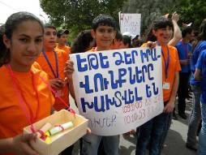
Artashat school children held posters
and disseminated fliers and leaflets
on child rights and juvenile justice
Recently 15 children from school #6 of Artashat town (Ararat province) had a meeting with the Human Rights Defender of Armenia. During the meeting they presented cases of child rights violence they had witnessed and looked for his advice on the ways to prevent, identify and respond to cases. Children’s complains mainly concerned the juvenile justice, especially the corporal punishment used against teenagers in the police custody.
Children picked this issue up during the common reading of the UN Convention on the Rights of the Child, empowered by the knowledge of rights. They spoke about cases, when their friends or acquaintances were taken to the police station without sufficient cause and subjected to severe corporal punishment and brutal interrogations in order to elicit confessions or information. Children frequently experienced violence at the hands of police because they are poor, ignorant of their rights, and lacking adults to whom they can turn for assistance. Silence and inaction allowed violence against children to continue.
The problem of children’s corporal punishment at the police custody was raised by parents too. Having been in such situations parents had felt helpless and hopeless, needing information what to do.
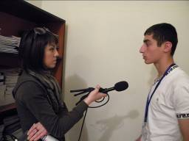
One of CtC group participants talking about
juvenile justice and encouraging his peers
not to be afraid of protecting their rights
When the issue was identified children were hesitant and reluctant to speak up for fear of reprisals. Having more discussions within the group and being supported by the skillful facilitators they got courage to start.
They decided to undertake a major campaign to end violence against children, bringing needed attention of the situation and to ensure that all children know and understand their human rights. Prior to the campaign, they studied the criminal code, had several meetings with relevant officials including the Human Rights Defender and a well-known official of the Republic of Armenia Police. Afterwards, children organized a rally on protection of juvenile rights on the streets of Artashat. They spread messages about protecting children’s rights at the police custody by disseminating leaflets containing children’s rights and the hot line phone number. Children also disseminated info via TV and radio interviews.

This and many other issues were raised by the “Child to Child” (CtC) groups of school children through the “Regional Children's Action for Participation” (ReCAP) program. ReCAP is a regional initiative that strives to achieve empowerment of children in Armenia, Azerbaijan and Georgia to play a leading role in their own development and the development of their communities through meaningful participation at local, national and regional levels.
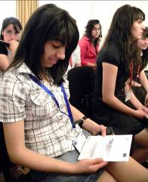Mariam Khachatryan, 11-grader: “We are not taught of our rights at schools. Thanks to our group meetings we have learned our rights and how to protect them.”
All in all, 80 groups with participation of 1,500 children will be established and run by the program in the capital city and five provinces. These children will learn about their rights set by the UN Convention on the Rights of the Child, and work together to promote proper implementation thereof. They will come up with proposals of legislative changes and advocate for their adoption by the Parliament.
Obviously, these activities will help children promote their rights. In doing this, children also practice forming and voicing their opinions as rights holders and learn to have active participation in issues that relate to them, which is the foremost goal of the program.

