EUROPEAN UNION

HEALTHY FOOD, HAPPY FAMILIES
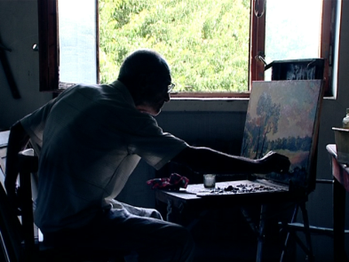
Khachik Manukyan likes painting since his childhood - his father used to paint, and he liked replicating. In 1960s they lived in Qazakh region of Azerbaijan. Later they settled in Armenia, and Khachik studied at the Medical College and then at Veterinary Institute. However, Khachik is still involved in painting both as a hobby and a source of income. And Khachik’s green garden outside of the house windows inspires him not only by its beauty but also good harvest – in winter he sells his paintings and in summer fruits and vegetables.
The windows of Khachik's house open to the green garden that provides healthy food and family income
In four villages of Ararat province – Hayanist, Sis, Nizami, and Khachpar – where Khachik lives – Save the Children implements a Rural Income Generation (RIG) project funded by the European Union. The project helps villagers to use a new gardening technology which requires less efforts, fertilizers and land yet promotes higher income by ensuring better productivity. Also, the vegetables grown through this methodology is of ecologically clean and higher quality.
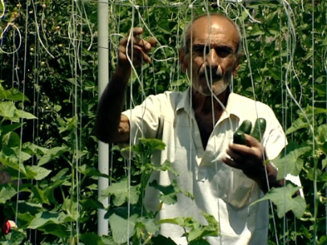
“I am very pleased with the new approach. Today I picked tomatoes from my garden for the first time. I showed it to my neighbour who usually buys tomatoes from the food market, and she got surprised – tomatoes looked great, the color inside it was dark red, and the taste was wonderful too,” says Khachik.
The vertical growing of the plants is the main specifics of the new methodology. Special cords and pillars are used in order to save ground space and increase ground usefulness coefficient. This methodology allows growing twice as much harvest as through the old methodology. Plus, the quality of the food increases since the plant gets full sun and is easily accessible for curing. The other peculiarity of the methodology is that only organic fertilizers are used in order to get healthy food.
“My garden provides ecologically clean vegetables for my family,” Khachik says.
50 families with approximately 200 people are involved in the project. In the beginning, many of the villagers – even those who agreed to be involved in the project – were skeptical about the new methodology. Now, when the success of the innovators’ is evident, the others regret they did not join them.
“Everybody knows that I sell ecologically clean product - tomato, cucumber, eggplant, squash, broccoli, beans and green pepper. I don’t even take it to the market. The villagers themselves come to me to buy vegetables. I thank them, and they thank me…”
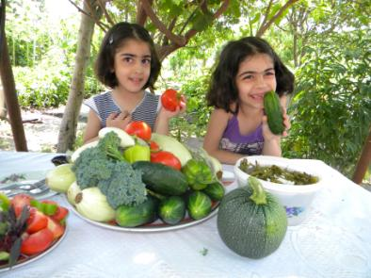
Communities involved in the project are 80 percent resided by refugees from Azerbaijan. “If this project was initiated some 20 years ago, many families would not leave the village,” Khachik says. “Many of those who settled in the village had fled from urban areas like Baku and Kirovabad, and did not have a clue about gardening. So they preferred to leave the village, and the land remained devastated.”
Project participants underwent training in Yerevan and their communities where they practiced their new skills and knowledge on every shrub and plant in the garden. Save the Children performed this work in partnership with the HDP Foundation.
Children enjoying healthy food raised by grown ups
“Committed to creating lasting change for children, Save the Children remains faithful to its mission through this project as well. By helping vulnerable families increase family income, we help children live in economically viable families and get healthy food which is an important precondition for being healthy, educated and protected,” says Irina Saghoyan, Director of Save the Children’s Armenian Representative Office.

